1. Data on Blanca’s datasheet for this paper were calculated from 3 Depths (Table. 2), Meng corrected a calculation error.

The paper does not report carbon density directly. We calculated carbon density from Table 2, which reported percent organic carbon and bulk density, but not carbon pool.

The bulk density and C% were averaged from 3 depths.

SC pool=soil C concentration * BD/**100**;

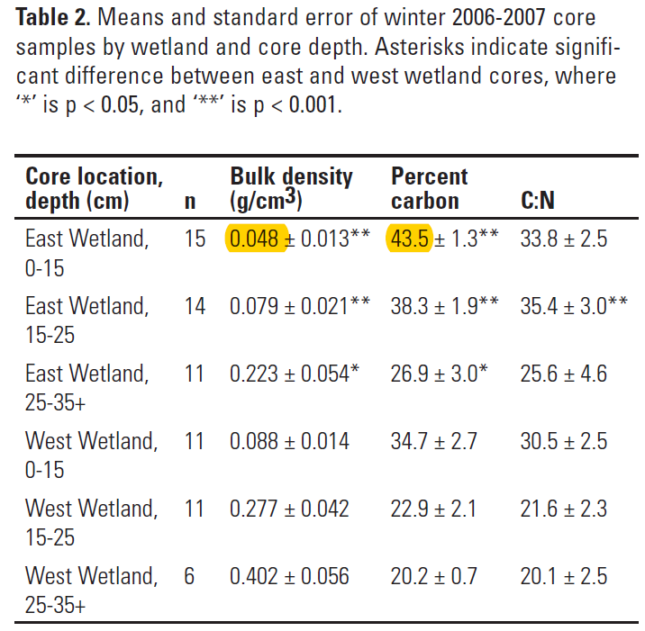

2. Data for soil C rate was calculated from Table 1.

Soil C rate =1000*SC*1.8 for site 1.

Soil C rate = 1000*SC*2 for site 2.

